Investigation into the effect of small molecule inhibitors on glioma cell migration

**Zara Ahmed**

University of Huddersfield, Huddersfield, HD1 3DH

|  |  |  |
| --- | --- | --- |
| A R T I C L E I N F O  Article history:  Received 07 November 22  Received in revised form 07 May 23  Accepted 24 May 23  Keywords:  Cancer  Glioblastoma  CCG-1423  Rhosin Hydrochloride (HCl)  Cell migration  Mesenchymal migration  Amoeboid migration  Collective migration  Actin |  | A B S T R A C T  This study aimed to observe the effect of anti-migratory drugs on glioblastoma (GBM) cell migration by targeting key pathways in migration, including actin polymerisation and RhoA – all of which channel cell migration. GBMs are a form of brain tumour originating in the brain in which they infiltrate surrounding brain tissues. Due to the invasive nature of glioma cells, treatment is difficult, resulting in current treatment options remaining ineffective in enhancing GBM survival rates. Cell migration plays an essential role in the invasion of GBM cells – ongoing research has revealed that targeting migratory pathways may be a complementary, novel treatment option as anti-migratory drugs may be used to inhibit cell migration and prevent cancer cell invasion in GBMs. This study aimed to gather further evidence for the use of anti-migratory drugs by investigating in vitro experimental methods for the assessment of a panel of anti-migratory inhibitors (CCG-1423 and Rhosin Hydrochloride) in the established U87 glioma cell line.  The methodology comprised immunofluorescence staining whereby the morphology (roundness) of cells and Corrected Total Cell Fluorescence (CTCF) of cellular actin was observed and analysed using ImageJ-Fiji software. CTCF results revealed that the use of CCG-1423 and Rhosin Hydrochloride (HCl) studied in combination were statistically significant to controlled-treated cells (p = 0.0037). The roundness of U87 cells illustrated a significant difference between Rhosin HCl-treated cells (p = 0.001) and combination-treated cells (p = 0.0037) compared to the control. Morphological analysis revealed novel findings with the use of CCG-1423 and Rhosin HCl utilised in combination for U87 gliomas – cells exhibited an alternative mode of migration, collective migration, in addition to mesenchymal or amoeboid migration. As such the use of CCG-1423 and Rhosin HCl in combination may trigger a third signalling pathway enabling collective migration. Crucially, the use of combination treatment for GBM allows the breakthrough for novel research to be examined further as combination drugs may pose therapeutic benefits in hindering glioma cell migration. |

**Introduction**

High-grade gliomas (HGG) are highly aggressive malignant tumours formed from glial cells in the brain, spreading to neighbouring brain tissues (Mesfin & Al-Dhahir, 2021). Due to the substantially low prognosis among glioblastoma (GBM) patients, treatment remains ineffective in preventing the spread and recurrence of tumours, leading to the most malignant and fatal brain tumour (Jovčevska, 2018). This study investigated grade 4 GBMs due to their invasive nature and the limited treatment options available. GBMs are difficult to treat because the cells develop tentacles that invade other regions of the brain – specifically in the frontal and temporal lobe; hence the surgical removal of GBMs proves to be challenging (Giglio & Villano, 2010). Thus, to prevent the invasion of GBM cells into neighbouring brain tissues, it is crucial to diagnose individuals in the early stages (Cheng et al., 2020).

The mortality rate in adults and children is high due to the highly invasive nature of GBMs; 80 out of a hundred individuals who are diagnosed with astrocytomas possess grade 4 GBM (Cancer Research UK, 2022). The effectiveness of prolonging survival rates of GBM patients remains low as research has revealed that individuals experience a three-month survival rate prior to treatment (Omuro & DeAngelis, 2013). Despite advancements in cancer therapeutics, survival rates remain low, thus discovering an alternative approach to prevent the invasion of gliomas, such as cell migration, is essential (Hirtz et al., 2020).

**Figure 1:** Schematic representation of the different forms of cell migration.Amoeboid migration (1A). Mesenchymal migration (1B). Collective migration (1C) (BioRender, 2022).

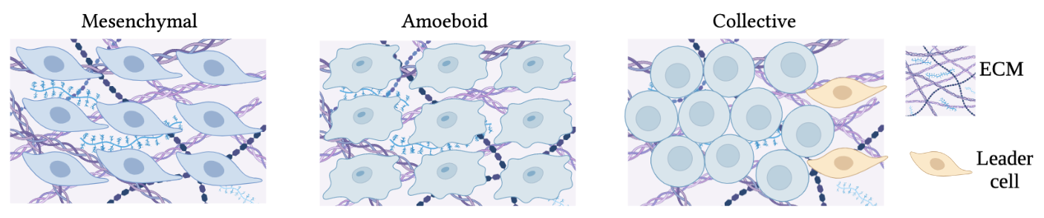

***Cell migration***

Cell migration contributes to the formation of tumours as it arises during the complete cascade of cancer development, leading to difficult-to-treat, invasive forms of cancer (Polacheck et al., 2012). GBM cell migration occurs in the extracellular matrix (ECM), and cells migrate along white matter tracts/blood vessels; the interaction between GBM cells and extracellular movements is achieved via transmembrane receptors in the brain (Mair et al., 2018). Glioma cells disperse from initial primary tumours as individual cells or sheets, leading to the disruption of healthy tissues (Armento et al., 2017). There are three forms of cell migration represented in Figure 1. Individual cells migrate by mesenchymal or amoeboid migration; cells migrating in sheets engage in collective migration. Tumour cell migration is maintained via integrins, matrix-degrading enzymes or cell-to-cell adhesion molecules (Friedl & Wolf, 2003). Thus, cells must degrade or change their shape to move through the ECM pores for migration to occur (Paňková et al., 2010).

*Mesenchymal migration*

GBM cells, such as the established U87 cell line, migrate in a mesenchymal manner – cells in a mesenchymal state exhibit an elongated morphology (Zhong et al., 2010). Mesenchymal migration relies on leading-edge protrusions activated by actin extensions, called lamellipodia, via cell polarisation.

Mesenchymal migration is facilitated due to the interactions of the Rho family, including Ras homolog guanine triphosphate (Rho GTPases), Ras-related C3 botulinum toxin substrate 1 (Rac1), active Rho and cell division control protein 42 (Cdc42), in which they cooperate as a group to maintain the actin cytoskeleton. Rho GTPases are a group of G signalling proteins engaged in cellular processes, such as the signal transduction pathway, switching from active and inactive forms to enable rapid cellular responses for cell migration (Hall, 2012).

Migratory proteins contribute to essential functions to ensure that the process of cell migration operates efficiently. Rho mediates the synthesis of stress fibres in actin; Rac1 regulates membrane protrusions and polymerisation of actin at the anterior of the cell to initiate protrusive forces in the form of lamellipodia (Mezzacappa et al., 2011). The initiation of Rac1 leads to protrusions of lamellipodia and actin polymerisation in which they perform in conjunction to enable cell polarisation. Cdc42 leads to actin-rich protrusions (filopodia) by maintaining cell directionality in aligning microtubules (Parri & Chiarugi, 2010).

A study by Yamazaki et al. (2005) utilised 3D invasion assays which revealed the importance of Rac1 and RhoA regulation contributing to the invasion of GBM cells via mesenchymal migration. Inhibition of Rac1 and Rho decreased U87 cell invasion in a series of assays – thus this approach can be focused in targeting mesenchymal pathways as a therapeutic target to prevent glioma cell migration using anti-migratory drugs (Yamazaki et al., 2005).

*Amoeboid migration*

Amoeboid migration is defined by the increased speed of motility. Amoeboid migration is mediated by actin-rich pseudopods crucial for the speed and directionality of cells – pseudopods are narrow extensions in which amoeboid movement is enabled as opposed to lamellipodia in mesenchymal migration (Van Haastert, 2011). Pseudopod extensions contribute to the spherical morphology displayed in amoeboid cells (Paňková et al., 2010). Cdc42 and Rho signalling molecules initiate the contraction of actomyosin; cell motility is driven by the activation of Rho-associated protein kinases (Rho/ROCK) transmission (Sahai & Marshall, 2003). Rho/ROCK signalling stimulates blebbing forming protrusions at the cell surface due to the contraction of actomyosin. During actomyosin contraction, cells participating in amoeboid migration alter their shape to enable rapid motility through the ECM pores (Matsuoka, 2014). In vitro morphological analysis revealed the effectiveness of combination-treated drugs in supressing amoeboid migration for breast cancer cells caused by the inhibition of ROCK/RhoA (Jones et al., 2017). Thus, amoeboid migration can be targeted by various small molecule inhibitors, including CCG-1423 and Rhosin HCl, to potentially treat GBMs, as shown in this research article.

*Collective migration*

Unlike mesenchymal and amoeboid cell migration, cells in collective migration migrate in clusters, strands, or sheets through cell-to-cell junctions (Jimenez et al., 2015). Collective migration is induced by the leader-follower polarisation mechanism whereby leader cells at the anterior of the sheet receive signals to direct follower cells to adopt collective migration (Yang et al., 2019). Previous research has revealed that targeting Rac and RhoA signalling pathways by anti-migratory drugs (CCG-1423 and Rhosin HCl) utilised in combination may induce a switch to collective migration (Ketchen et al., 2021). This illustrates the important role of RhoA and Rac in the collective migration of cells to further confirm the practicality of studying anti-migratory drugs for therapeutic intervention.

***Limited treatment options for glioblastoma***

Existing treatment for GBM involves maximal surgical resection followed by concurrent radiation with temozolomide (TMZ – oral chemotherapy agent) and chemotherapy with TMZ (Davis, 2016). However, complications arise during complete surgical resection due to the invasive behaviour of GBM cells. The complete elimination of primary tumour masses cannot be eradicated due to the infiltrative activity of heterogenous GBM cells in which they invade surrounding brain tissues, leading to its recurrence and progression in invasion (Lara-Velazquez et al., 2017).

Despite this, maximal resection remains useful in increasing survival rates as Yamaguchi et al. (2012) concluded that maximal resection of GBM patients prolongs the overall median survival rate by 23.4 months, whereas incomplete resection does not increase the survival rate (15.3 months). According to Stupp et al. (2014), the addition of TMZ to radiotherapy led to a two-month increase in median survival rate, providing the most significant improvement in GBM survival. Another beneficial, but not as effective drug as TMZ, is Bevacizumab (antiangiogenic agent). Although it does not increase the survival rate of individuals, it does improve the symptomatic management (Carter et al., 2018).

Nonetheless, curing GBM remains difficult as GBM cells can migrate and invade neighbouring tissues, leading to ineffective therapeutic outcomes (Mahmoud et al., 2017). Thus, it is necessary to discover alternative ways to treat GBM, such as targeting anti-migratory pathways to inhibit cell migration and invasion.

**Figure 2:** Mechanism of Rhosin HCl inhibition produced in Microsoft Word, Version 16.52.Without Rhosin HCl cell migration is upregulated via RhoA activation (A). With Rhosin HCl cell migration is inhibited via RhoA deregulation (B).



***Inhibition of cell migration by novel anti-migratory inhibitors***

The discovery of small molecule inhibitors has facilitated the advancement of potential treatments in cancer therapy as a way of targeting pathways in cellular processes to prevent GBM invasion, such as cell migration (Liu et al., 2022). In this research I utilised two novel anti-migratory drugs (CCG-1423 and Rhosin HCl), individually and in combination. This was to observe the migratory behaviour and morphology of U87 glioma cells by detecting the distribution of actin, which plays a key role in cell motility. Developing drugs that enable delivery across the blood-brain barrier to reach the brain may pose therapeutic benefits in directly targeting tumour cells (Tang et al., 2021).

*Rhosin HCl inhibitor*

Extracellular responses induce cell migration, such signalling molecules include GTPases, involved in cell migration. Rho family GTPases mediate the formation of actin structures and regulate cell migratory mechanisms (cell-to-cell adhesion) (Ridley, 2001). The contraction of actin is maintained by GTPases, Rac and Rho. Rhosin HCl, a small molecule inhibitor, can be used as an anti-migratory drug by acting to prevent the migration and invasion of tumours. Rhosin HCl does this by hindering the attachment of guanosine nucleotide exchange factors (GEF) to RhoA (Figure 2). RhoA is upregulated in GBM to mediate migration (Butler, 2021). Thus, Rhosin HCl thereby acts to inhibit the regulation of the actin cytoskeleton. Therefore, less protein is available for cell migration to persist due to possible reduced levels of actin. This results in the prevention of GBM invasion due to a decrease in cell migration. Promising studies by Tsbuaki et al. demonstrated the inhibition of breast cancer cell migration by utilising Rhosin HCl; this targeted RhoA and RhoC to decrease CXR4 receptor levels using siRNA treatment (Tsubaki et al., 2021). Such studies indicate the potential therapeutic benefit of utilising Rhosin HCl to cell migration in other cancers.

*CCG-1423 inhibitor*

CCG-1423 (Figure 3) has commonly been used as a small molecule inhibitor in cancer therapeutics to prevent cell migration. CCG-1423 uses an alternative approach to inhibit cell migration by supressing the interaction between serum response factor (SRF) and oncogene megakaryoblast leukaemia transcriptional co-activator protein 1 (MKL1) whereby cancer is usually upregulated (Sun et al., 2006).

**Figure 3:** Mechanism of CCG-1423 inhibiting cell migration produced in Microsoft Word, Version 16.52 (Microsoft Corporation, 2018).Without CCG-1423 cell migration is upregulated SRF activation via MKL1 (A). With CCG-1423 cell migration is inhibited via SRF inactivation of MKL1 inhibition (B).

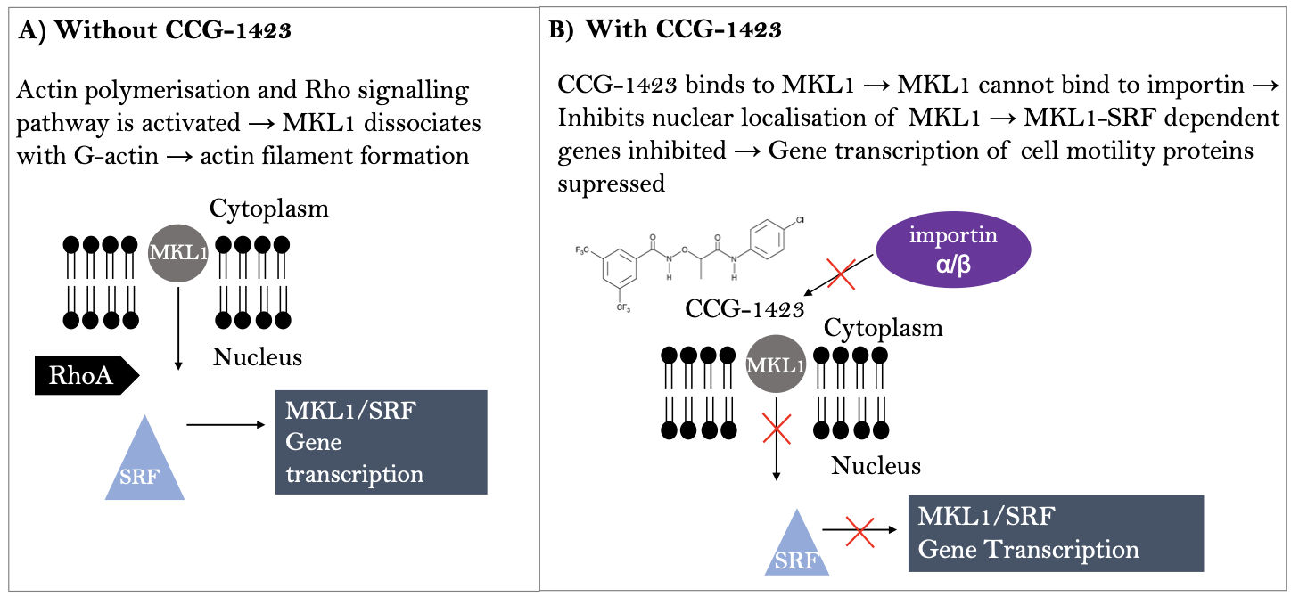

Under regular conditions, MKL1 is bound to G-actin via the N-terminal basic domain. Thus, during the activation of Rho signalling pathways via actin polymerisation, MKL1 and G-actin dissociate for the synthesis of actin filaments; this leaves MKL1 in an unbound state in the cytoplasm. During the unbound state, importin α/β (a transport protein complex), imports MKL1 into the nucleus – this results in the formation of the transcription complex between MKL1 and SRF to initiate gene transcription. However, CCG-1423 acts to inhibit this process by binding to the NB domain on MKL1; thereby inhibiting the attachment of importin α/β to MKL1 – hence, gene transcription cannot proceed to potentially inhibit cell migration (Ketchen, 2019). The transcription of genes which mediate cell migration are inhibited – thus CCG-1423 inhibits the polymerisation of actin by regulating Molecules Interacting with CasL (MICAL2) which codes for F-actin. MICAL2 is a novel cancer gene initiating mesenchymal-epithelial transition in the invasion and growth of tumours (Mariotti et al., 2015). Research accompanied by Evelyn et al. by microarray analysis revealed that CCG-1423 inhibits Rho/MLK/SRF-mediated transcription by RhoA/C inhibition to prevent the invasion of PC-3 prostate cancer (Evelyn et al., 2016). These pathways are crucial for cell migration to occur (Gau et al., 2017) – inhibition of RhoA/C via anti-migratory drugs (CCG-1423) can prevent the initiation of cell migration. Although this study provided promising results, the direct molecular targets of CCG-1423 remain unknown at present as multiple genes may lead to the induction of RhoA/RhoC, thereby further analysis must be conducted to validate these findings (Evelyn et al., 2010).

Due to the continued failure of treating and slowing down the progression of GBM with commonly used treatment regimes, it is vital to explore alternative, effective treatments in preventing GBM invasion. Targeting migratory pathways using small molecule inhibitors has opened a new gateway for the pharmacological intervention of GBM cell migration inhibition. The use of novel anti-migratory drugs (in combination and uniquely) can be used as a potential target for the transcription of specific genes to prevent tumour cells from migrating to other sites of the brain.

***Aims and objectives***

This study aimed to evaluate the effect of two small molecule inhibitors on actin dispersal to prevent cell migration in GBM cells. The small molecule inhibitors, CCG-1423 and Rhosin HCl, were studied alone and in combination by utilising the established U87 cell line to target vital migratory pathways, such as actin polymerisation and RhoA transcriptional pathways, in which cell migration is mediated.

Two-dimensional in vitro assays were carried out to assess the effect of the inhibitors on the migration of U87 cells by detecting the actin dispersal with the assistance of brightfield and confocal imaging. Two-dimensional assays were investigated using immunofluorescence staining (phalloidin and 6-diamidino2-phenylindol - DAPI dyes) and fixation to observe the effect of small molecule inhibitors on the level of actin in U87 cells – this allowed changes in morphology to be investigated indicating the mode of random migration adopted by the cells.

***Research ethics***

Ethical approval for this study was not sought as the study was conducting experiments on an established cell line. Therefore, it was not necessary to gain ethical approval before experimentation began.

**Materials and methods**

In the current study GBM cells from the U87-MG cell line gathered by Pontén and Macintyre (Pontén & Macintyre, 1968) were utilised. U87 cells were supplied by American Type Culture Collection (ATCC) (Ledur et al., 2017).

The guidance for working with the cell line were followed (see Figure 4 and Figure 5). Utilising these procedures served to ensure that cross-contamination of the sample was prevented. U87 cells were tested and found to be mycoplasma (contamination) free, verified by short tandem repeat (STR) profiling at the University of Leeds.

***Cell passage***

Prior to determining the effect of anti-migratory behaviour of U87 cells, cells were passaged close to confluence under sterile conditions (80%). T and the medium was made up of f 5ooml Dulbecco’s Modified Eagle’s Medium of high glucose (DMEM, Sigma), 50 ml 10% Foetal Calf Serum (FCS) (Sigma-Aldrich) and 5 ml Penicillin-Streptomycin (Sigma-Aldrich). The cell solution from the flask was discarded and washed with 5 ml Phosphate Buffered Saline (PBS – Sigma-Aldrich) – the PBS was discarded. Two ml of trypsin (Sigma-Aldrich) was pipetted into the flask and incubated. After incubation, 8 ml of media was pipetted into the flask.

In two new flasks, 5 ml of media and 5 ml of cell suspension (from the original flask) was pipetted. The flask was incubated for seven days until the following passage.

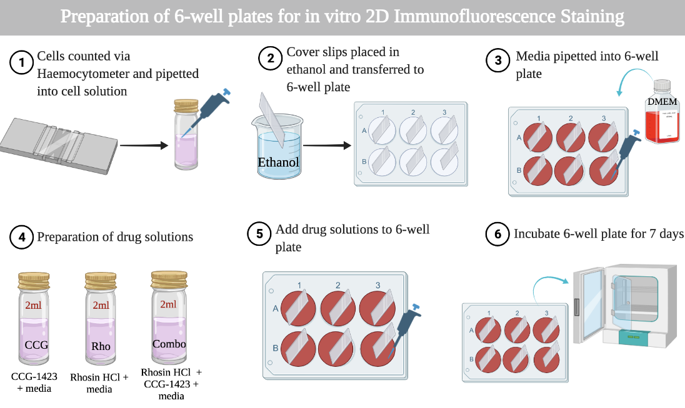

**Figure 4:** Schematic illustration of the 6-well plate experimental set-up produced in BioRender. 6-well plates were prepared in vitro for immunofluorescence analysis (BioRender, 2022).

***Preparation of 6-well plates for immunofluorescence***

In this study, 6-well plates were prepared for immunofluorescence staining (see Figure 4). The average number of cells were counted using a haemocytometer – allowing the required volume to be calculated at a cell density of 2.5x103 cells/ml media. Coverslips were dipped into 100% methanol and placed into the 6-well plate for two minutes in an upward position. The cells suspended in 2 ml of medium were pipetted into each plate and left for three hours. The drugs (CCG and Rhosin HCl) were prepared using the following dilutions: 2.0 µl of 500 nM CCG-1423 per 2 ml media and 2.0 µl of CCG-1423 with 2.0 µl Rhosin HCl per 2 ml media to produce the combination suspension; 2 ml of drug suspension was pipetted into corresponding wells to replace the original medium while the remaining three wells were left unchanged (control). The 6-well plates were incubated for seven days at 37°C prior to immunofluorescence staining.

***2D immunofluorescence staining and fixation***

The 6-well plate was removed from the incubator and the medium was discarded (Figure 5); each coverslip was washed PBS. To fix the cells, 4% paraformaldehyde (PFA) was pipetted to each well and left at room temperature for 15 minutes.

The staining solution was prepared by diluting 1 µl 6-diamidino-2-phenylindole (DAPI) (FAK100, Sigma-Aldrich) and 1 µl phalloidin (FAK100, Sigma-Aldrich) into 1000 µl blocking solution (0.1% skimmed milk powder and PBS), this was made up to 1200 µl to allow 200 µl staining solution to be pipetted into each well. DAPI staining visualises the nucleus and phalloidin detects the actin cytoskeleton.

After 15-minutes, PBS-Triton X-100 solution was pipetted into the 6-well plate and incubated for five minutes. Cells were washed with PBS in each well, and blocking solution was added. The dye solution was centrifuged for five minutes in Eppendorf tubes (Sigma-Aldrich). The incubation chamber was set up, and 200µl staining solution was placed onto the parafilm with the coverslips and left for one hour. The coverslips were placed onto 6-well plates and washed with PBS. They were mounted with Fluoromount G (Sigma-Aldrich) onto glass slides and allowed to airdry covered in foil at room temperature overnight prior to EVOS and confocal imaging.

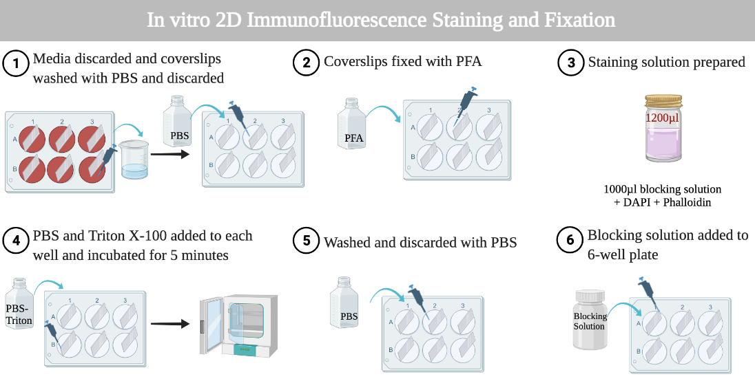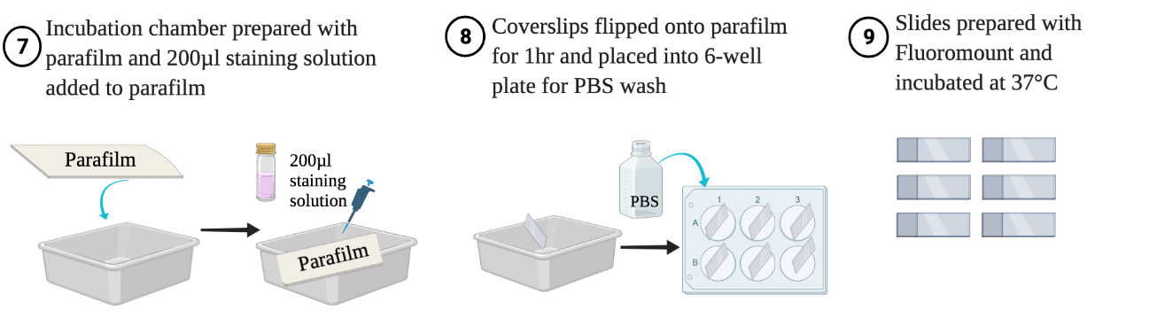

**Figure 5:** Schematic Representation of immunofluorescence staining, and fixation produced in BioRender. Immunofluorescence allowed morphological analysis and actin localisation observations(BioRender, 2022).

***EVOS and confocal imaging***

Immunofluorescence imaging was carried out using EVOS FLoid Imaging System. Confocal analysis (Zeiss LSM 880) was used to observe the distribution of actin and morphological changes of U87 cells via phalloidin and DAPI.

***ImageJ-Fiji analysis***

ImageJ-Fiji (Schindelin et al., 2012) was used for the quantitative analysis of cells by immunofluorescence staining. The Corrected Total Cell Fluorescence (CTCF) was calculated for each condition in U87 cells and compared against the control to detect a significant difference in actin levels after the addition of anti-migratory drugs.

CTCF was calculated using the following formula: Integrated Density – (Area of selected cell * Mean fluorescence of background readings) (The Open Lab Book, 2022). The morphology of cells was calculated by measuring the roundness of cells on ImageJ-Fiji by enabling the following commands: *Measure* → *Shape descriptors*. This indicated the possible mode of migration adopted by the cells.

***Statistical analysis***

To undertake statistical analysis, Statistical Package for the Social Sciences (IBM SPSS Statistics, Version 26) was used to calculate the roundness and CTCF of U87 cells. A test for normality was carried out (Shapiro-Wilk) for actin levels and roundness of U87 cells. For CTCF, the data was normally distributed and a One-way ANOVA test of four samples was compared within sample variability. The data for roundness was non-parametric and a Kruskal-Wallis Test was used. Due to statistically significant data, a Post Hoc test was carried via Tukey and Bonferroni for CTCF and roundness, respectively to determine statistically different groups.

**Results**

**Figure 6:** Confocal (Zeiss LSM 880) images captured for untreated and treated U87 cells at x10 and x40 magnification. Confocal analysis allowed morphological analysis of U87 cells and the effect of anti-migratory drugs on glioma cell migration. The U87 cells were stained with phalloidin (red) and 6-diamidino2-phenylindol (DAPI, blue) to detect the actin and DNA, respectively. The untreated cells presented an elongated morphology (A, B). CCG-1423-treated cells presented an enlarged morphology (C, D). Rhosin HCl-treated cells appeared larger in size (E, F). Combination-treated cells had the largest effect, forming sheet-like structures (G, H). Scale bar = 20µm and 80µm.

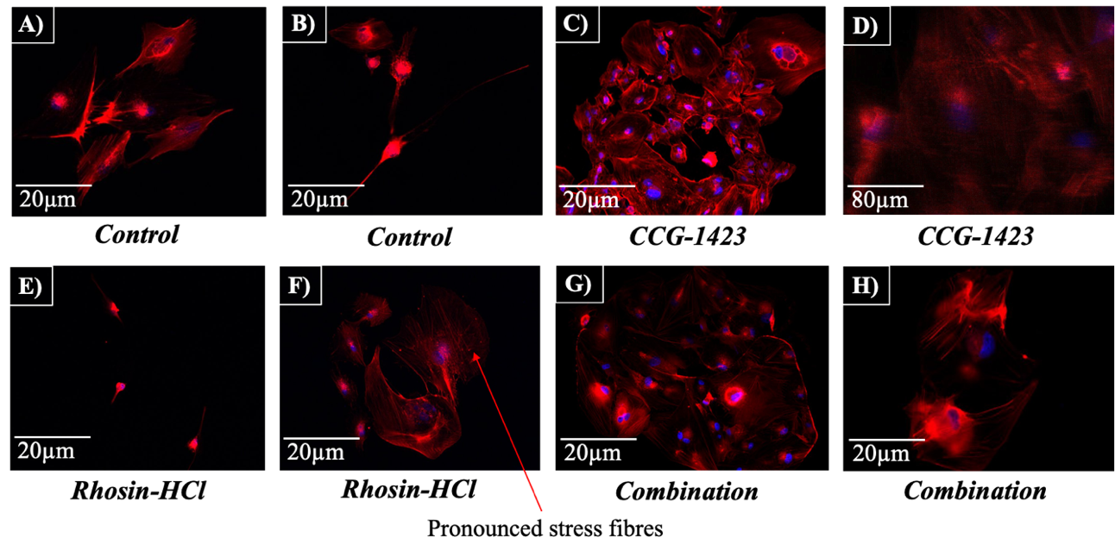

***Confocal microscopy***

Confocal analysis allowed the investigation of the actin cytoskeleton and morphology of U87 cells to be observed at high resolutions – the intensity of the signal on the confocal microscope was proportional to the amount of protein present responsible for the synthesis of actin.

Prior to treatment (control), Figure 6A and 6B revealed that the cells presented an elongated morphology, thus were in a mesenchymal state of migration with few stress fibres displayed (red). The use of anti-migratory drugs may have influenced the cell size and morphology as cells possessed an enlarged morphology (Figures 6C–6H). The addition of Rhosin HCl gave rise to pronounced stress fibres on the edge of the cell and induced the formation of seemingly larger and rounder cells (Figure 6F) – thus Rhosin HCl may influence the cell size of U87 cells.

**Figure 7:** Images captured on the EVOS (EVOS FLoid Imaging System) for quantification analysis of untreated and treated U87 cells at x10 magnification. Images were used to calculate actin levels (CTCF) and roundness of U87 cells via ImageJ-Fiji (Schindelin et al., 2012). Cells were stained with phalloidin and 6-diamidino2-phenylindol (DAPI) to highlight the actin and DNA, respectively. Untreated cells exhibited the most actin (A). Treated cells presented the least levels of actin (B, C, D). Scale bar = 20µm.

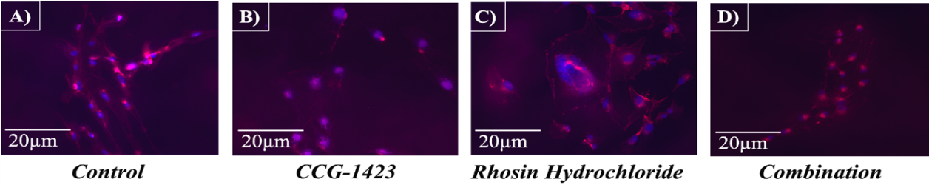

The effect of CCG-1423 on U87 cells in Figure 6C highlighted the presence of actin on the surface of the cell appearing to be clumped together with a larger morphology compared to the control – indicating the effect of CCG-1423 on the majority of U87 cells. Distinct features from combination-treated cells were observed, the actin distributed on the surface of the cell with the cells presented in a pronounced sheet-like structure rather than single cells, unlike the other conditions.

***EVOS images for the quantification analysis of actin levels and roundness***

Similar findings were observed in the cytoskeletal features of U87 cells by EVOS imaging. Figure 7 represents the images captured on the EVOS for the quantification of actin levels and roundness of U87 cells. As displayed in Figure 7A, the untreated U87

cells appeared to be smaller with increased actin fluorescence (red). CCG-1423-treated u87 cells (Figure 7B) expressed less actin; a reduction in actin fluorescence indicated a decrease in protein levels synthesised for cell migration. Similarly, Rhosin HCl-treated cells (Figure 7C), expressed fewer actin; however, in contrast to CCG-1423, the cells displayed a rounder and larger morphology. In Figure 7D, the combination treatment contained the least actin fluorescence in U87 cells in which the cells appeared to form a cluster-like structure.

|  |  |
| --- | --- |
| **Condition** | **Average CTCF of Actin in U87 Cells** |
| Control | 806896.88 |
| CCG-1423 | 731513.86 |
| Rhosin Hydrochloride | 737791.97 |
| Combination | 490986.32 |

**Table 1.** Average CTCF of actin levels for each condition using U87 Cells. After drug addition, the CTCF decreased compared to the control, specifically with the combination treatment in which the CTCF decreased significantly, p = 0.0037). CTCF was analysed via ImageJ-Fiji (Schindelin et al., 2012) and the average CTCF of three replicates was calculated via Microsoft Excel, Version 16.52 (Microsoft Corporation, 2018).

The CTCF indicated the level of actin in each cell – Table 1 revealed that the addition of CCG-1423, Rhosin HCl and combination-treated drugs to U87 cells led to a reduction in actin levels compared to the control. CCG-1423 and Rhosin HCl had similar levels of CTCF compared to the combination, whereas the combination treatment induced the highest reduction in CTCF of actin in comparison to the control. The control represented untreated U87 cells with the use of no drugs and medium only.

Figure 8 displays a steady decline in actin levels of U87 cells for CCG-1423, Rhosin HCl and combination treatment compared to the control with CCG-1423 and Rhosin HCl posing similar effects. The combination treatment presented the highest variability with a significant difference of p = 0.005, whereas CCG-1423 and Rhosin HCl presented the least variability in actin levels. This revealed that combination treatment of CCG-1423 and Rhosin HCl may influence cell migration due to the rapid decrease in actin within U87 glioma cells.

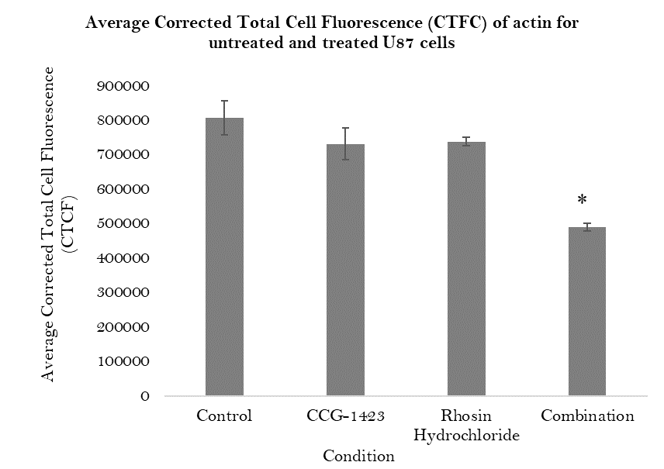

**Figure 8**: Graphical representation of average CTCF of actin levels in untreated and treated U87 cells. Levels of actin decreased with the addition of CCG-1423, Rhosin HCl and combination. Combination-treated cells were significantly lower compared to the control (p=0.0037). Asterisks indicated the level of significance (* = P < 0.05).

***Statistical analysis for the CTCF of actin for untreated and treated U87 cells***

To validate whether there was a significant difference between the control and drug treatments for U87 cells, appropriate statistical analysis was carried out. The results for ANOVA illustrated a significant difference between the four conditions used for U87 cells (p = 0.005). The purpose of ANOVA was to observe the variability within the sample of data between sample variability. During ANOVA, it was assumed that all the populations exhibited a normal distribution with the same variance and standard deviation – all samples were assumed to be randomly selected and independent of other groups (null hypothesis). The null hypothesis was rejected as this was not the case; a Post Hoc test was carried out to observe which groups were significantly different from the control. P < 0.05 proved significance. The Post Hoc test, (Tukey) obtained via SPSS Version 26 predictive analytics software, showed that there was a significant difference between control and combination-treated cells (p = 0.0037). In parallel, there was a significant difference between CCG-1423 and combination-treated cells (p = 0.006).

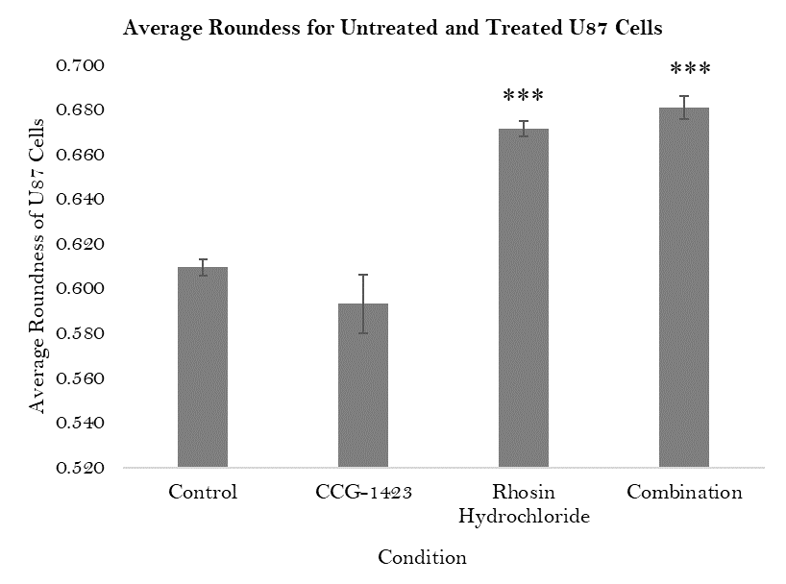

**Figure 9:** Graphical representation of average roundness for untreated and treated U87 cells. Rhosin HCl (p = 0.000) and combination (p = 0.000) U87 cells were significantly rounder than the control. Asterisks indicated the level of significance (*** = P < 0.001).

|  |  |
| --- | --- |
| **Condition** | **Average Roundness of U87 cells** |
| Control | 0.610 |
| CCG-1423 | 0.593 |
| Rhosin Hydrochloride | 0.672 |
| Combination | 0.681 |

**Table 2.** Average roundness for untreated and treated U87 cells. Control and CCG-1423-treated cells were less spherical, combination and Rhosin HCl-treated cells were rounder – similar to the combination treatment. Roundness was analysed with via ImageJ-Fiji (Schindelin et al., 2012); average roundness of three replicates was calculated using Microsoft Excel

***Roundness of untreated and treated U87 cells***

The roundness of cells was investigated to observe which migration type U87 cells had adopted. Table 2 illustrates the roundness of cells for all three repeats. Results revealed that with the addition of CCG-1423, U87 cells decreased in roundness (0.593). Contrastingly, when Rhosin HCl and combination treatment were utilised, U87 cells developed a rounded morphology with values of 0.672 and 0.681, respectively. The control did not contain any treatment and only medium was present during the preparation, hence the U87 cells did not become rounder and remained in a mesenchymal state. In a graphical representation, Figure 9 illustrates that untreated U87 cells displayed an elongated morphology, but when treated with Rhosin HCl they became rounder. The sudden increase in Rhosin HCl and combination treatment may have indicated the type of migration U87 cells adopted. Rhosin HCl and combination treatment displayed a highly significant difference in contrast to the control (***) with a p value of 0.000 for the two drug treatments – this confirmed that there was a difference between the two treatments on U87 cell morphology.

The null hypothesis assumed no statistical difference within the datasets. Statistical analysis was carried out on SPSS Version 26.

The test for normality indicated that the data was non-parametric (P < 0.05 proved significance). The Kruskal-Wallis Test denoted that there was a significant difference between the conditions (p = 0.000) – the null hypothesis was rejected. The Post Hoc test (Bonferroni) revealed a significant difference between control and Rhosin HCl (p = 0.000) and control and combination (p = 0.000). This confirmed the effect on the use of anti-migratory drugs in comparison to the untreated cells.

**Discussion**

Due to the poor prognosis and highly devastating disease outcome of GBM, it is crucial to discover advanced effective ways to prolong survival rates of GBM patients. Thus, the purpose of this study aimed to distinguish anti-migratory effects of small molecule inhibitors on glioma cell migration as a potential therapeutic target for combination treatment of GBM. Two-dimensional in vitro studies were conducted to examine the effect of CCG-1423 and Rhosin HCl on random cell migration in glioma cells, specifically U87 cells. The general synopsis concluded that it was evident for the reduction in glioma cell migration within combination-treated U87 cells. Combination-treated gliomas provided optimistic findings that had not been reported before in the current literature with the use of 2D assays, as opposed to drugs utilised individually.

***Anti-migratory drugs affecting actin levels in gliomas***

Glioma cells were modelled in 2D assays via in vitro methods to detect the random migratory effect of anti-migratory drugs. This novel approach was successfully achieved as actin levels decreased with the addition of anti-migratory drugs, suggesting a reduction in cell migration. This was reinforced as there was a significant reduction (p = 0.045) in the level of actin compared to the control when CCG-1423 and Rhosin HCl were utilised in combination.

CCG-1423, a small molecule inhibitor, acts to inhibit the interaction between MKL and SRF. Thus, the transcription of genes inducing migration are suppressed, causing the upregulation of MICAL2 and depolymerisation of actin. This potentially justifies the reduction in actin levels (Gau et al., 2017). Despite this, CCG-1423 did not play a crucial role in completely inhibiting glioma cell migration due to the possible upregulation of MICAL2 and inability to supress MKL-SRF interaction. To confirm this statement, Western blot analysis could be carried out in a further experimental analysis to observe if CCG-1423 failed to block MKL-SRF interaction by analysing SRF protein expression (Kaneda et al., 2018). Gau et al. (2017) demonstrated the inhibitory behaviour of CCG-1423 upon the formation of actin filaments due to MKL1 and G-actin dissociation. Contrastingly, as CCG-1423 did not inhibit cell migration in this project, the actin filaments may not have formed as G-actin and MKL1 remained in the bound state – MKL1 must be unbound for actin polymerisation to occur (Gau et al., 2017).

In support of the findings gathered from this project, CCG-1423 failed to inhibit U87 cell migration in a study established by Butler (Butler, 2021) with the use of 2D immunofluorescence and 3D spheroid models; in parallel, Ketchen et al. revealed that CCG-1423 did not pose a great influence in reducing U87 cell migration (Ketchen et al., 2020). CCG-1423 may only pose therapeutic benefits in inhibiting cell migration for specific cancer cells – as discussion previously, CCG-1423 successfully inhibited cell migration in PC-3 prostate cancer (Evelyn et al., 2016). Therefore, these studies denote that CCG-1423 proves successful in distinct forms of cancer.

Another potent inhibitor studied in this project was Rhosin HCl, whereby it acts to suppress Rho GTPases. Rhosin HCl acts by binding to trp58 GEF binding site on RhoA to suppress RhoA activation. The inactivation of RhoA inhibits GEF attaching to Rho GTPases (Shang et al., 2012) leading to the deregulation of intermediate filaments through stress fibre formation, the suppression of cell migration and reduction in actomyosin contractility (Butler, 2021).

Similar to the findings obtained from CCG-1423-treated cells, Rhosin HCl-treated cells did not present a reduction in actin compared to the control in this study. This implies that RhoA remained activated to increase the production of actin filaments and regulation of protrusions, therefore allowing cell migration to continue due to actin formation (Kraynov et al., 2000). In contrast, in vitro studies conducted by Shang et al. (2012) revealed that the use of Rhosin in breast cancer cells inhibited cell migration and invasion activity at variable doses by targeting RhoA and RhoC signalling molecules. Rhosin blocked stress fibre formation and RhoA activity – the suppression of RhoA and RhoC prevented the invasion of breast cancer cells (Shang et al., 2012).

For this project, the dose of Rhosin HCl may have been too low for the generation of RhoA activation. Therefore, Rhosin HCl did not directly induce a reduction in glioma cell migration.

Despite the utilisation of individual drugs with no discernible impact on actin levels in gliomas, the use of CCG-1423 and Rhosin HCl in combination delivered promising results. Combination-treated cells revealed a significant reduction in actin levels with actin localised in the centre of the cell, demonstrating that combination-treated drugs may decrease actin levels by reducing the level of migratory proteins required to inhibit migration (Wu et al., 2021).

Actin is an essential component in driving cancer cell migration as it enables cell motility. The reorganisation of actin is maintained via Rho family small GTPases, including Rho, Rac and Cdc42, all of which channel extracellular chemotactic signals to downstream effectors. Consequently, the inhibition of Rho family small GTPases may lead to a decline in chemostatic signals to cell migration and the invasion of tumour cells.

This novel project gave an insight into the potential treatments of cancer by targeting actin using small molecule inhibitors which as a result may minimise glioma cell migration (Yamazaki et al., 2005). This became evident as the presence of actin was visibly reduced in drug-treated cells compared to the control, indicating that Rho family small GTPases may be inhibited (RhoA and Rac) to suppress chemotactic signals and reduce migration. Research conducted by Lin and Zheng (2015) showed that targeting individual pathways of migration by individual drugs reduces the efficacy; drugs utilised in combination with other anti-cancer drugs that target multiple pathways produce significant clinical advantages to achieve the desired effect of minimising cell migration in cancer therapy .

***Morphological analysis of individual treatment indicating mesenchymal or amoeboid migration***

The roundness of glioma cells was investigated as an indication of how anti-migratory drugs influenced the morphology and mode of migration of U87 cells. Statistical analysis confirmed a significant difference between the control and combination-treated cells (p = 0.000) and control and Rhosin HCl-treated cells (p = 0.000). An amoeboid pathway of migration may be exhibited by cells treated with Rhosin HCl due to the globular morphology revealed in Figure 6F. Thus, the effect of Rhosin HCl on glioma cells signified an enlarged morphology with pronounced stress fibres.

Amoeboid cells migrate in a rapid fashion, indicating that glioma cells in an amoeboid state travel quicker through the ECM. To completely inhibit migration this pathway must be inhibited as cells in amoeboid migration travel through narrow gaps in the ECM by alternating their shape to a rounded morphology (van Zijl et al., 2011). Studies have illustrated that targeting RhoA pathways can prove to be challenging due to the lack of pockets available for efficient binding – in the case of this study the Rhosin HCl inhibitor may have been outcompeted by GEF, causing a mediation in migration rather than inhibition (Kristelly et al., 2004).

Alternatively, CCG-1423 had no morphological effect and cells remained elongated in a mesenchymal state of migration. The actin appeared on the surface of the cell, whereas in controlled-glioma cells the actin was internally distributed. Studies have demonstrated the elongated movement of gliomas induced by Rac1 activation; CCG-1423 possibly induced Rac1 causing the suppression of actomyosin contractility to prevent the formation of rounded cells (Sanz-Moreno, 2012). A study directed by Taylor et al. denoted that CCG-1423 promote a switch from a mesenchymal-to-amoeboid transition (MAT) in glioma cells (Taylor et al., 2017), which was further confirmed by Ketchen (2019). The induction of MAT was potentially due to CCN1 inhibition by CCG-1423. These findings differed to this project as gliomas were studied in terms of actin dispersal and remained in a mesenchymal mode with the treatment of CCG-1423. To further progress this study, the level of CCN1 could be utilised as a biomarker to detect whether CCG-1423 influences CCN1 secretion, caused by actin depolymerisation and RhoA activation to inhibit cell migration (Zhao et al., 2014).

***Morphological analysis of combination treatment reveals potential induction of collective migration in gliomas***

Novel findings in this research project established by in vitro 2D assays marked the effective use of combination treatment on the inhibition of glioma cell migration – these outcomes had not been disclosed in the current literature. Interestingly, cells induced a third mode of migration (collective migration) due to the sheet-like structure observed here, indicating that CCG-1423 and Rhosin HCl in combination may target two different signalling pathways which divert to a third pathway directing collective cell migration. Hence, anti-migratory drugs used in combination can be used to implicitly inhibit glioma cell migration. Comparable to the findings from this research project, Ketchen et al. also confirmed the sheet-like behaviour of combination-treated drugs (CCG-1423 and Rhosin HCl). Novel discoveries revealed that cells treated in combination drugs switched to collective migration in comparison to individual inhibitors which exhibited single-cell migration (Ketchen et al., 2021).

Collective migration was potentially observed in this project. Cancer cells harbouring a collective mode of migration present an increased plasticity and migratory activity (Wu et al., 2021). However, the obstacle arises because although the cells move slowly during collective migration (0.3µm /min), they are still moving (Zhang et al., 2017). Cells undergoing collective migration can invade surrounding healthy tissues; therefore, it is crucial to inhibit this process when treating GBM. To efficiently inhibit collective migration, an additional drug can be used in conjunction with CCG-1423 and Rhosin HCl to target the third signalling pathway and essentially inhibit cell migration in glioma cells (such as Ursolic acid). Conway et al. (2021) revealed that the use of novel drugs, such as Ursolic acid, may inhibit the collective migration of GBM cells via 2D scratch assays. Sub-toxic levels of Ursolic acid inhibited the collective migration of U251 glioma cells by disrupting Jun N-terminal Kinase (JNK) independent signalling pathways (Conway et al., 2021). Hence, this paves a path for the therapeutic effects of anti-migratory drugs and the influence they have on GBM cell migration, which can be used with CCG-1423 and Rhosin HCl in combination to observe anti-migratory activities. Conclusions from this study can add to the advancement of future research as an indication of the effectiveness of combination treatments in targeting glioma cell migration.

Ultimately, in vitro 2D assays provided an insight into the effectiveness of identifying actin levels and morphological changes of untreated and treated GBM cells by inhibiting migration. CCG-1423 did not substantially influence actin levels and morphological changes within U87 cells; Rhosin HCl induced a switch from mesenchymal-to-amoeboid transition. As actin levels in combination-treated drugs were statistically lower compared to the control, there may have been an inhibition in cell migration. Novel findings gathered from morphological analysis revealed the sheet-like behaviour of combination-treated GBM cells which can be further targeted by other anti-migratory inhibitors. In terms of drug development for forthcoming analysis, patients could be given three drugs used in combination; to reduce risk factors it may be safer to prescribe one inhibitor targeting regulators upstream of the signalling pathways to induce all three pathways driving cell migration. This approach would potentially inhibit cell migration completely rather than slowing it down in glioma cells to prevent the invasion/spread of tumours. Despite this, studies have illustrated the effectiveness of drugs used in combination and are safe to use depending on the dosage of administration, providing anti-cancer benefits (Mokhtari et al., 2017).

**Conclusion**

This study highlighted the discovery of novel inhibitors that supports research that sought to establish a potential treatment in inhibiting glioma cell migration using anti-migratory inhibitors. Standard therapy remains ineffective in prolonging lives with a current 12-month survival rate due to the infiltrative behaviour of recurring GBM cells.

In the current study the migratory activities of glioma cells in response to anti-migratory drugs concluded that combination-treated drugs significantly minimised actin levels and induced collective migration. CCG-1423 and Rhosin HCl-treated gliomas did not individually influence migration, although a change in morphology was observed by Rhosin HCl. Based on the overall results presented here, combination-treated gliomas with anti-migratory drugs may point towards inhibiting cell migration to prevent tumour invasion to other regions of the brain by targeting migratory signalling pathways (Rho GTPases).

Although combination treatments exhibited promising results as U87 cells switched to collective migration, thus greatly slowing down cell migration, the addition of a third drug (Ursolic acid) could potentially target this third signalling pathway to prevent the migration of gliomas entirely. In parallel, the use of one drug could be used to target a potential key regulator of all three signalling pathways to prevent GBM cell migration to other parts of the brain rather than challenging a patient in an already weakened condition with three different drugs as this may reduce the effectiveness of the treatment. Additionally, it may be ideal to utilise different cell lines when observing migratory effects as Liu et al. concluded that targeting purine metabolism drugs revealed an increase in toxicity for U251 cell lines as opposed to U87 cells – U251 expressed higher levels of proteins involved in drug resistance (Liu et al., 2022). This emphasises the potential need for personalised drugs for specific cell lines due to the heterogenous nature of GBM cells; this has not been reported in present literature and would increase the possibility of treating GBM patients.

Nevertheless, novel findings observed in this study add to the discovery of therapeutic drugs and the effect they have on GBM treatment in combination with cytotoxic drugs, such as TMZ, as current treatment remains ineffective in increasing survival rates of GBM patients. Thus, the findings in this study would greatly enhance the development in discovering techniques to target migratory pathways and authenticate the use of combination drugs.

**Acknowledgements**

I would like to thank my supervisor, Dr Anke Brüning-Richardson, for her continued support and guidance throughout the duration of this project.

I would also like to thank her and her laboratory team in the laboratory for facilitating access to the necessary cells and reagents needed to conduct my project.

**References**

Armento, A., Ehlers, J., Schötterl, S., & Naumann U. (2017). Molecular mechanisms of glioma cell motility. *Glioblastoma*, 73–93. <https://doi.org/10.15586/codon.glioblastoma.2017.ch5>

BioRender. (2022). https://biorender.com/

Butler, H. (2021). Combination treatment with migrastatic inhibitors to target brain tumour spread. *Fields: Journal of Huddersfield Student Research*, *7*(1). https://doi.org/10.5920/fields.823

Cancer Research UK. (2022). Astrocytoma and glioblastoma (GBM). Brain and spinal cord tumours. <https://www.cancerresearchuk.org/about-cancer/brain-tumours/types/astrocytoma-glioblastoma-multiforme>

Carter, T. C., Medina-Flores, R., & Lawler, B. E. (2018). Glioblastoma treatment with temozolomide and bevacizumab and overall survival in a rural tertiary healthcare practice. *BioMed Research International*, 1–10. https://doi.org/10.1155/2018/6204676

Cheng, Y., Bao, W., & Wu, Q. (2020). Cerebral hemispheric glioblastoma with PNET-like morphology and histone H3.3 G34 mutation in younger patients: Report of three rare cases and diagnostic pitfalls. *Indian Journal of Pathology and Microbiology*, *63*(2), 262. <https://doi.org/10.4103/ijpm.ijpm_544_19>

Conway, G. E., Zizyte, D., Mondala, J. R. M., He, Z., Lynam, L., Lecourt, M., Barcia, C., Howe, O., & Curtin, J. F. (2021). Ursolic acid inhibits collective cell migration and promotes JNK-Dependent lysosomal associated cell death in glioblastoma multiforme cells. *Pharmaceuticals*, *14*(2), 91. https://doi.org/10.3390/ph14020091

Davis, M. (2016). Glioblastoma: Overview of disease and treatment. *Clinical Journal of Oncology Nursing*, *20*(5), S2–S8. https://doi.org/10.1188/16.cjon.s1.2-8

Evelyn, C. R., Bell, J. L., Ryu, J. G., Wade, S. M., Kocab, A., Harzdorf, N. L., Hollis Showalter, H. D., Neubig, R. R., & Larsen, S. D. (2010). Design, synthesis and prostate cancer cell-based studies of analogs of the Rho/MKL1 transcriptional pathway inhibitor, CCG-1423. *Bioorganic & Medicinal Chemistry Letters*, *20*(2), 665–72. https://doi.org/10.1016/j.bmcl.2009.11.056

Evelyn, C., Lisabeth, E., Wade, S., Haak, A., Johnson, C., Lawlor, E., & Neubig, R. (2016). Small-molecule inhibition of Rho/MKL/SRF transcription in prostate cancer cells: Modulation of cell cycle, ER stress, and metastasis gene networks. *Microarrays*, *5*(2), 13. https://doi.org/10.3390/microarrays5020013

Friedl, P., & Wolf, K. (2003). Tumour-cell invasion and migration: Diversity and escape mechanisms. *Nature Reviews Cancer*, *3*(5), 362–74. https://doi.org/10.1038/nrc1075

Gau, D., Veon, W., Capasso, T. L., Bottcher, R., Shroff, S., Roman, B. L., & Roy, P. (2017). Pharmacological intervention of MKL/SRF signaling by CCG-1423 impedes endothelial cell migration and angiogenesis. *Angiogenesis*, *20*(4), 663–72. <https://doi.org/10.1007/s10456-017-9560-y>

Giglio, P., & Villano, J. L. (2010). Newly diagnosed high-grade gliomas. *Current Treatment Options in Neurology*, *12*(4), 309–20. https://doi.org/10.1007/s11940-010-0077-6

Hall, A. (2012). Rho family GTPases. *Biochemical Society Transactions*, *40*(6), 1378–82. <https://doi.org/10.1042/bst20120103>

Hirtz, A., Rech, F., Dubois-Pot-Schneider, H., & Dumond, H. (2020). Astrocytoma: A hormone-sensitive tumor? *International Journal of Molecular Sciences*, *21*(23), 9114. <https://doi.org/10.3390/ijms21239114>

Jimenez, V. A. M., Wu, P.-H., Yogurtcu, O. N., Rao, P., DiGiacomo, J., Godet, I., He, L., Lee, M.-H., Gilkes, D., Sun, S. X., & Wirtz, D. (2015). Collective cancer cell invasion induced by coordinated contractile stresses. *Oncotarget*, *6*(41), 43438–51. <https://doi.org/10.18632/oncotarget.5874>

Jones, B. C., Kelley, L. C., Loskutov, Y. V., Marinak, K. M., Kozyreva, V. K., Smolkin, M. B., & Pugacheva, E. N. (2017). Dual targeting of mesenchymal and amoeboid motility hinders metastatic behavior. *Molecular Cancer Research*, *15*(6), 670–82. https://doi.org/10.1158/1541-7786.mcr-16-0411

Jovčevska, I. (2018). Genetic secrets of long-term glioblastoma survivors. *Bosnian Journal of Basic Medical Sciences*. https://doi.org/10.17305/bjbms.2018.3717

Kaneda, M., Sakagami, H., Hida, Y., Ohtsuka, T., Satou, N., Ishibashi, Y., Fukuchi, M., Krysiak, A., Ishikawa, M., Ihara, D., Kalita, K., & Tabuchi, A. (2018). Synaptic localisation of SRF coactivators, MKL1 and MKL2, and their role in dendritic spine  
morphology. *Scientific Reports*, *8*(1). https://doi.org/10.1038/s41598-017-18905-7

Ketchen, S. E. (2019). *Targeting the actin polymerisation pathway for improved treatment of glioblastoma.* White Rose eTheses Online. <https://etheses.whiterose.ac.uk/25184/1/Ketchen%20SE%2C%20School%20of%20Medicine%2C%20PhD%2C%202019.pdf>

Ketchen, S., Rohwedder, A., Knipp, S., Esteves, F., Struve, N., Peckham, M., Ladbury, J. E., Curd, A., Short, S. C., & Brüning-Richardson, A. (2020). A novel workflow for three-dimensional analysis of tumour cell migration. *Interface Focus*, *10*(2), 20190070. https://doi.org/10.1098/rsfs.2019.0070

Ketchen, S. E., Gamboa-Esteves, F. O., Lawler, S. E., Nowicki, M. O., Rohwedder, A., Knipp, S., Prior, S., Short, S. C., Ladbury, J. E., & Brüning-Richardson, A. (2021). Drug resistance in glioma cells induced by a mesenchymal–amoeboid migratory switch. *Biomedicines*, *10*(1), 9. <https://doi.org/10.3390/biomedicines10010009>

Kraynov, V. S., Chamberlain, C., Bokoch, G. M., Schwartz, M. A., Slabaugh, S., & Hahn, K. M. (2000). Localized Rac activation dynamics visualized in living  
Cells. *Science*, *290*(5490), 333–7. https://doi.org/10.1126/science.290.5490.333

Kristelly, R., Gao, G., & Tesmer, J. J. G. (2004). Structural determinants of RhoA binding and nucleotide exchange in leukemia-associated Rho guanine-nucleotide exchange factor. *Journal of Biological Chemistry*, *279*(45), 47352–62. https://doi.org/10.1074/jbc.m406056200

Lara-Velazquez, M., Al-Kharboosh, R., Jeanneret, S., Vazquez-Ramos, C., Mahato, D., Tavanaiepour, D., Rahmathulla, G., & Quinones-Hinojosa, A. (2017). Advances in brain tumor surgery for glioblastoma in adults. *Brain Sciences*, *7*(12), 166. https://doi.org/10.3390/brainsci7120166

Ledur, P. F., Onzi, G. R., Zong, H., & Lenz, G. (2017). Culture conditions defining glioblastoma cells behavior: What is the impact for novel discoveries? *Oncotarget*, *8*(40), 69185–97. https://doi.org/10.18632/oncotarget.20193

Lin, Y., & Zheng, Y. (2015). Approaches of targeting Rho GTPases in cancer drug discovery. *Expert Opinion on Drug Discovery*, *10*(9), 991–1010. https://doi.org/10.1517/17460441.2015.1058775

Liu, H., Qiu, W., Sun, T., Wang, L., Du, C., Hu, Y., Liu, W., Feng, F., Chen, Y., & Sun, H. (2022). Therapeutic strategies of glioblastoma (GBM): The current advances in the molecular targets and bioactive small molecule compounds. *Acta Pharmaceutica Sinica B*, *12*(4), 1781–804. https://doi.org/10.1016/j.apsb.2021.12.019

Mahmoud, O., Tunceroglu, A., Chokshi, R., Benevenia, J., Beebe, K., Patterson, F., & DeLaney, T. F. (2017). Overall survival advantage of chemotherapy and radiotherapy in the perioperative management of large extremity and trunk soft tissue sarcoma; a large database analysis. *Radiotherapy and Oncology*, *124*(2), 277–84. <https://doi.org/10.1016/j.radonc.2017.07.021>

Mair, D. B., Ames, H. M., & Li, R. (2018). Mechanisms of invasion and motility of high-grade gliomas in the brain. *Molecular Biology of the Cell*, *29*(21), 2509–15. <https://doi.org/10.1091/mbc.e18-02-0123>

Mariotti, S., Barravecchia, I., Vindigni, C., Pucci, A., Balsamo, M., Libro, R., Senchenko, V., Dmitriev, A., Jacchetti, E., Cecchini, M., Roviello, F., Lai, M., Broccoli, V., Andreazzoli, M., Mazzanti, C. M., & Angeloni, D. (2015). MICAL2is a novel human cancer gene controlling mesenchymal to epithelial transition involved in cancer growth and invasion. *Oncotarget*, *7*(2), 1808–25. https://doi.org/10.18632/oncotarget.6577

Matsuoka, T. (2014). Rho/ROCK signaling in motility and metastasis of gastric cancer. *World Journal of Gastroenterology*, *20*(38), 13756. https://doi.org/10.3748/wjg.v20.i38.13756

Mesfin, F. B., & Al-Dhahir, M. A. (2021). *Gliomas*. Nih.gov; StatPearls Publishing. <https://www.ncbi.nlm.nih.gov/books/NBK441874/>

Mezzacappa, C., Komiya, Y., & Habas, R. (2011). Activation and function of small GTPases Rho, Rac, and Cdc42 during gastrulation. *Methods in Molecular Biology*, 119–31. <https://doi.org/10.1007/978-1-61779-510-7_10>

Microsoft Corporation. (2018). Microsoft Excel. https://office.microsoft.com/excel

Mokhtari, R. B., Homayouni, T. S., Baluch, N., Morgatskaya, E., Kumar, S., Das, B., & Yeger, H. (2017). Combination therapy in combating cancer. *Oncotarget*, *8*(23), 38022–43. https://doi.org/10.18632/oncotarget.16723

Omuro, A., & DeAngelis, L. M. (2013). Glioblastoma and other malignant gliomas. *JAMA*, *310*(17), 1842. <https://doi.org/10.1001/jama.2013.280319>

Paňková, K., Rösel, D., Novotný, M., & Brábek, J. (2010). The molecular mechanisms of transition between mesenchymal and amoeboid invasiveness in tumor cells. *Cellular and Molecular Life Sciences*, *67*(1), 63–71. <https://doi.org/10.1007/s00018-009-0132-1>

‌ Parri, M., & Chiarugi, P. (2010). Rac and Rho GTPases in cancer cell motility control. *Cell Communication and Signaling*, *8*(1). <https://doi.org/10.1186/1478-811x-8-23>

Polacheck, W. J., Zervantonakis, I. K., & Kamm, R. D. (2012). Tumor cell migration in complex microenvironments. *Cellular and Molecular Life Sciences*, *70*(8), 1335–56. <https://doi.org/10.1007/s00018-012-1115-1>

Pontén, J., & Macintyre, E. H. (1968). Long term culture of normal and neoplastic human glia. *Acta pathologica et microbiologica Scandinavica*, *74*(4), 465–86.

Ridley, A. J. (2001). Rho GTPases and cell migration. *Journal of Cell Science*, *114*(15), 2713–22. https://doi.org/10.1242/jcs.114.15.2713

Sahai, E., & Marshall, C. J. (2003). Differing modes of tumour cell invasion have distinct requirements for Rho/ROCK signalling and extracellular proteolysis. *Nature Cell Biology*, *5*(8), 711–19. https://doi.org/10.1038/ncb1019

Sanz-Moreno, V. (2012). Tumour invasion: A new twist on Rac-driven mesenchymal migration. *Current Biology*, *22*(11), 449–51. https://doi.org/10.1016/j.cub.2012.04.024

Schneider, C. A., Rasband, W. S., & Eliceiri, K. W. (2012). NIH Image to ImageJ: 25 years of image analysis. Nature Methods, 9(7), 671–675. <https://doi.org/10.1038/nmeth.2089>

Shang, X., Marchioni, F., Sipes, N., Evelyn, Chris R., Jerabek-Willemsen, M., Duhr, S., Seibel, W., Wortman, M., & Zheng, Y. (2012). Rational design of small molecule inhibitors targeting RhoA subfamily Rho GTPases. *Chemistry & Biology*, *19*(6), 699–710. <https://doi.org/10.1016/j.chembiol.2012.05.009>

Stupp, R., Brada, M., van den Bent, M. J., Tonn, J.-C., & Pentheroudakis, G. (2014). High-grade glioma: ESMO clinical practice guidelines for diagnosis, treatment and follow-  
up. *Annals of Oncology*, *25*, 93–101. https://doi.org/10.1093/annonc/mdu050

Sun, Y., Boyd, K., Xu, W., Ma, J., Jackson, C. W., Fu, A., Shillingford, J. M., Robinson, G. W., Hennighausen, L., Hitzler, J. K., Ma, Z., & Morris, S. W. (2006). Acute myeloid leukemia-associated *Mkl1 (Mrtf-a)* is a key regulator of mammary gland  
function. *Molecular and Cellular Biology*, *26*(15), 5809–26. https://doi.org/10.1128/mcb.00024-06

Tang, D. D., & Gerlach, B. D. (2017). The roles and regulation of the actin cytoskeleton, intermediate filaments and microtubules in smooth muscle cell migration. *Respiratory Research*, *18*(1). https://doi.org/10.1186/s12931-017-0544-7

Tang, L., Feng, Y., Gao, S., Mu, Q., & Liu, C. (2021). Nanotherapeutics overcoming the blood-brain barrier for glioblastoma treatment. Frontiers In Pharmacology, 12. <https://doi.org/10.3389/fphar.2021.786700>

Taylor, S., Knipp, S., Rohwedder, A., Curd, A., Struve, N., Peckham, M., Ladbury, J., Short, S. C., & Bruning-Richardson, A. (2017). The migratory switch: Investigating mesenchymal-amoeboid transition (MAT) in high grade gliomas. *Neuro-Oncology*, *19*(6), 22. <https://doi.org/10.1093/neuonc/nox168.082>

The Open Lab Book. (2022). Measuring cell fluorescence using ImageJ v1.0. <https://theolb.readthedocs.io/en/latest/imaging/measuring-cell-fluorescence-using-imagej.html>

Tsubaki, M., Genno, S., Takeda, T., Matsuda, T., Kimura, N., Yamashita, Y., Morii, Y., Shimomura, K., & Nishida, S. (2021). Rhosin suppressed tumor cell metastasis through inhibition of Rho/YAP pathway and expression of RHAMM and CXCR4 in melanoma and breast cancer cells. *Biomedicines*, *9*(1), 35. <https://doi.org/10.3390/biomedicines9010035>

Van Haastert, P. J. M. (2011). Amoeboid cells use protrusions for walking, gliding and swimming. *PLoS ONE*, *6*(11), 27532. https://doi.org/10.1371/journal.pone.0027532

van Zijl, F., Krupitza, G., & Mikulits, W. (2011). Initial steps of metastasis: Cell invasion and endothelial transmigration. *Mutation Research/Reviews in Mutation Research*, *728*(1–2), 23–34. <https://doi.org/10.1016/j.mrrev.2011.05.002>

Wu, J., Jiang, J., Chen, B., Wang, K., Tang, Y., & Liang, X. (2021). Plasticity of cancer cell invasion: Patterns and mechanisms. *Translational Oncology*, *14*(1), 100899. <https://doi.org/10.1016/j.tranon.2020.100899>

Yamaguchi, S., Kobayashi, H., Terasaka, S., Ishii, N., Ikeda, J., Kanno, H., Nishihara, H., Tanaka, S., & Houkin, K. (2012). The impact of extent of resection and histological subtype on the outcome of adult patients with high-grade gliomas. *Japanese Journal of Clinical Oncology*, *42*(4), 270–7. <https://doi.org/10.1093/jjco/hys016>

Yamazaki, D., Kurisu, S., & Takenawa, T. (2005). Regulation of cancer cell motility through actin reorganization. *Cancer Science*, *96*(7), 379–86. https://doi.org/10.1111/j.1349-7006.2005.00062.x

Yang, Y., Zheng, H., Zhan, Y., & Fan, S. (2019). An emerging tumor invasion mechanism about the collective cell migration. *American Journal of Translational Research*, *11*(9), 5301–12. https://www.ncbi.nlm.nih.gov/pmc/articles/PMC6789225/

Zhang, Y., Xu, G., Lee, R. M., Zhu, Z., Wu, J., Liao, S., Zhang, G., Sun, Y., Mogilner, A., Losert, W., Pan, T., Lin, F., Xu, Z., & Zhao, M. (2017). Collective cell migration has distinct directionality and speed dynamics. *Cellular and Molecular Life Sciences*, *74*(20), 3841–50. https://doi.org/10.1007/s00018-017-2553-6

Zhao, X., Ding, E. Y., Yu, O. M., Xiang, S. Y., Tan-Sah, V. P., Yung, B. S., Hedgpeth, J., Neubig, R. R., Lau, L. F., Brown, J. H., & Miyamoto, S. (2014). Induction of the matricellular protein CCN1 through RhoA and MRTF-A contributes to ischemic cardioprotection. *Journal of Molecular and Cellular Cardiology*, *75*, 152–61. https://doi.org/10.1016/j.yjmcc.2014.07.017

Zhong, J., Paul, A., Kellie, S. J., & O’Neill, G. M. (2010). Mesenchymal migration as a therapeutic target in glioblastoma. *Journal of Oncology*, *2010*, 1–17. https://doi.org/10.1155/2010/430142